Youtube Video

<https://youtu.be/fnIpIs4UqVs?si=jJrFvQ_EYVvMrlVv>

**step 1:**

**download xlsx module**

<https://apps.odoo.com/apps/modules/9.0/report_xlsx>

pip install xlsxwriter

pip install xlrd

step 2:

'depends' : ['report_xlsx'],

# create **excel_report_actions.xml file inside report directory**

'data' : [  
 'security/ir.model.access.csv',  
 'views/school.xml',  
 'report/excel_report_actions.xml',  
],

# inside excel_report_actions.xml file

<?xml version="1.0" encoding="utf-8"?>  
<odoo>  
 <record id="student_excel_report_action" model="ir.actions.report">  
 <field name="name">Student Report</field>  
 <field name="model">school.student</field>  
 <field name="report_type">xlsx</field>  
 <field name="report_name">school.students_excel_report</field>  
 <field name="report_file">school.students_excel_report</field>  
 <field name="binding_model_id" ref="model_school_student"/>  
 <field name="binding_type">report</field>  
 <field name="attachment_use" eval="False"/>  
 </record>  
</odoo>

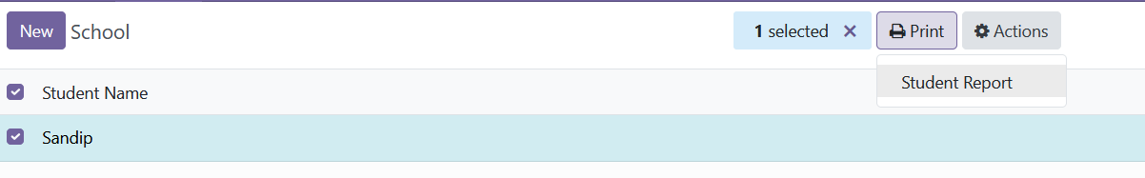

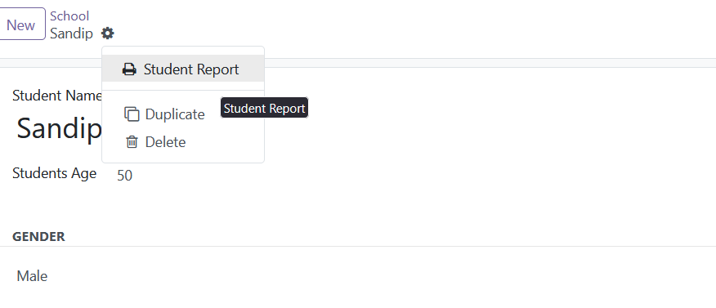

Create __init__.py file in report directory and create new .py file

student_excel_report.py

from odoo import models  
  
class PartnerXlsx(models.AbstractModel):  
 _name = 'report.school.students_excel_report'  
 _inherit = 'report.report_xlsx.abstract'  
  
 def generate_xlsx_report(self, workbook, data, partners):  
 for obj in partners:  
 report_name = obj.name  
 # One sheet by partner  
 sheet = workbook.add_worksheet(report_name[:31])  
 bold = workbook.add_format({'bold': True})  
 sheet.write(0, 0, obj.name, bold)

**and imprt report directory in root __init__.py file**

from . import models  
from . import report

**set multiple records**

from odoo import models  
  
class PartnerXlsx(models.AbstractModel):  
 _name = 'report.school.students_excel_report'  
 _inherit = 'report.report_xlsx.abstract'  
  
 def generate_xlsx_report(self, workbook, data, partners):  
 bold = workbook.add_format({'bold': True})  
 sheet = workbook.add_worksheet('Student Report')  
 row = 0  
 col = 0  
 for obj in partners:  
 row += 1  
 sheet.write(0, 0, 'Name', bold)  
 sheet.write(row, 0, obj.name)  
  
 sheet.write(0, 1, 'Age', bold)  
 sheet.write(row, 1, obj.age)  
  
 sheet.write(0, 2, 'Gender', bold)  
 sheet.write(row, 2, obj.gender)

**set column width** sheet.set_column('A:C',50)

from odoo import models  
  
class PartnerXlsx(models.AbstractModel):  
 _name = 'report.school.students_excel_report'  
 _inherit = 'report.report_xlsx.abstract'  
  
 def generate_xlsx_report(self, workbook, data, partners):  
 bold = workbook.add_format({'bold': True})  
 sheet = workbook.add_worksheet('Student Report')  
 sheet.set_column('A:C',50)  
 row = 0  
 col = 0  
 for obj in partners:  
 row += 1  
 sheet.write(0, 0, 'Name', bold)  
 sheet.write(row, 0, obj.name)  
  
 sheet.write(0, 1, 'Age', bold)  
 sheet.write(row, 1, obj.age)  
  
 sheet.write(0, 2, 'Gender', bold)  
 sheet.write(row, 2, obj.gender)

**Set murge column**